Clinical presentation
- There will be 2 clinical presentations and one guest lecture per month
2nd & 4th Wednesday – clinical presentation
3rd Wednesday – Guest Lecture
- Presentation – 40 min + Inspirational Video – 5 min + Discussion – 15 min

Scheduled Dates
Jan | 21 | 4.00p.m. – 5.00p.m. | My Life My Journey -  Student – Ms. Ruvina  Bachelor of Nursing
 | 28 | 4.00p.m.- 5.00p.m. | Future of health care  Dr. Nihal De Silva, MD, MPH, ACOG  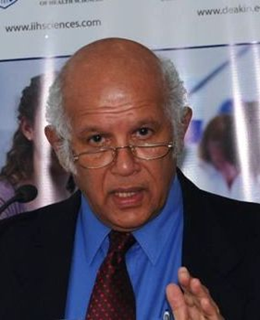  Dean - IIHS

